**St. Francis Institute of Technology**

**Class: SE-ITA/ITB Semester: IV; A.Y. 2023-2024**

**Subject: Microprocessor Lab**

**Experiment – 8:** Transfer block of data using string instructions

**1. Aim**:

Write an ALP to transfer a block of data from data segment to extra segment using string instructions and display the block of data on the output screen.

**2. Requirements**

DOSBox (an x86 emulator with DOS), Turbo Assembler, Turbo Debugger

**3. Pre-Experiment Exercise**

**Data transfer using string instruction:** A string is a series of bytes stored sequentially in the memory. String instructions operate on such “String”. The source element is taken from the Data Segment using the SI register. The destination element is in the Extra Segment pointed by the DI register. SI and/or DI are incremented/ decremented after each operation depending upon the direction flag “DF” in the Flag register. String instruction used in this program is MOVSB which is used to transfer a byte from Data Segment to Extra Segment. The instruction is used with a prefix REP which stands for repeat. The instruction is repeated CX number of times, the SI and DI registers are incremented and decremented based on the Direction Flag and CX is decremented.

Display data on dos-prompt: INT 21h is a Dos interrupt that allows a programmer to interact with the input and output devices. To write a character to standard output, load the character to DL register and use the following command.

**MOV AH,02H**

**INT 21**

Please note that output devices work with ASCII numbers so appropriate care must be taken to convert the character to equivalent ASCII number.

**Algorithm:**

A. Initialize a block of data in array1 in the data segment and empty block in array 2 in the extra segment.

B. Load the respective effective address in SI and DI register.

C. Initialize the CX register as counter to the size of the block.

D. Use string instruction to transfer the block of data from data segment to extra segment. E. Reload the effective address in SI register and initialize the CX register as a counter. F. Use INT 21h and associated options to display the block on dos-prompt.

**4. Laboratory Exercise:**

**Procedure:**

A. Open DOSbox and go to TASM.

B. Open a new document using the command - edit <filename>.asm

C. Write the Program and save the changes to the same file.

D. Assemble the program using the command - tasm <filename.asm>

E. If any errors are displayed, then change the code in <filename>

F. If no errors are displayed, execute the command - tlink <filename>.obj to create the executable file.

G. Next execute the command - td <filename>

H. Try to RUN the program step by step. Check both data segment and extra segment to observe the transfer of data.

I. Execute again using the command - <filename> to observe the block displayed on the dos prompt.

**5. Post Experiment Exercise:**

**A. Results/Calculations/Observations:**

Along with ALP, attach two screenshots.

i. One after MOVSB instruction has been executed.

ii. Second after the data has been displayed on the output screen.

**B. Questions:**

i. Write in detail about the following String Instructions.

(a) LODS (b) STOS (c) CMPS (d) SCAS

ii. List the different REP prefixes used with string instructions.

**C. Conclusion:**

Write the conclusion/comments based on the experiment performed and the output obtained. **D. References:**

Mention two book references and two web references.

Code:

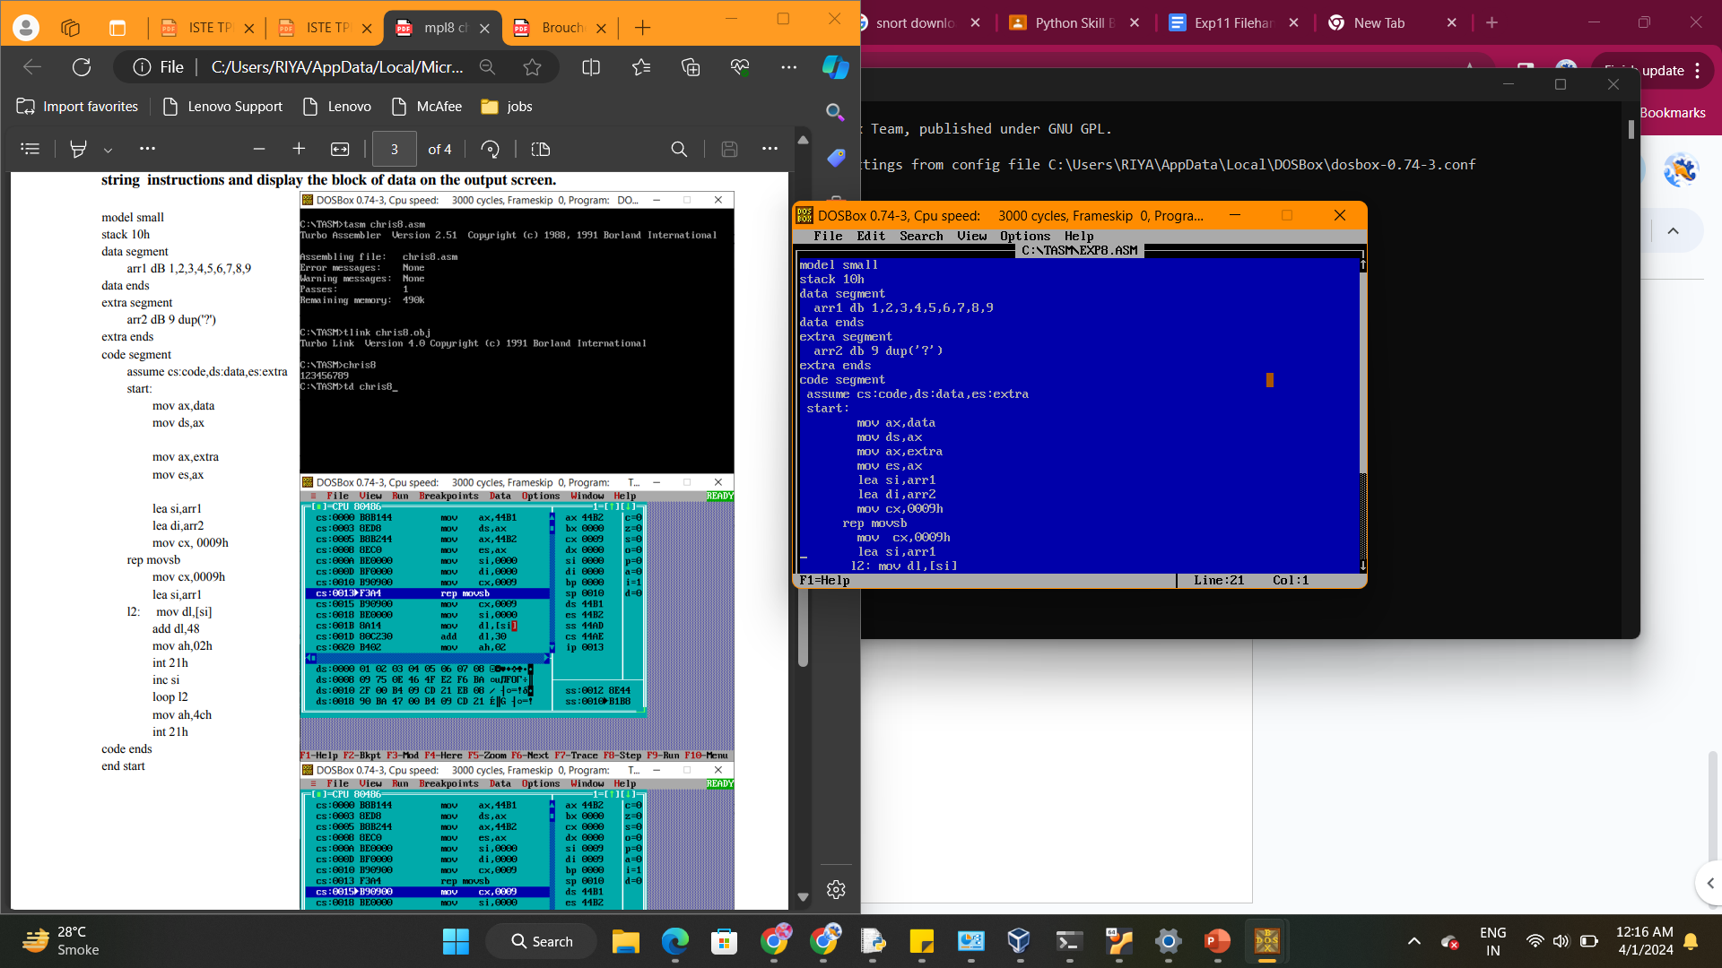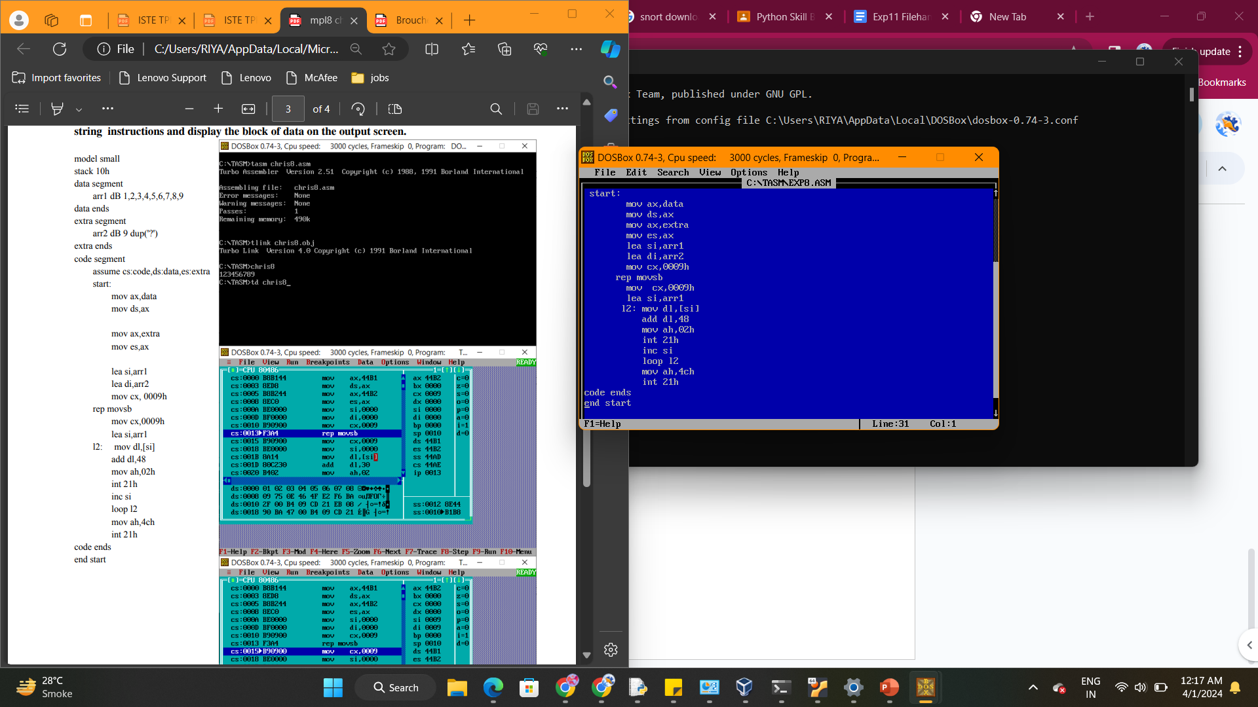

Output:

